w 1/6(W)

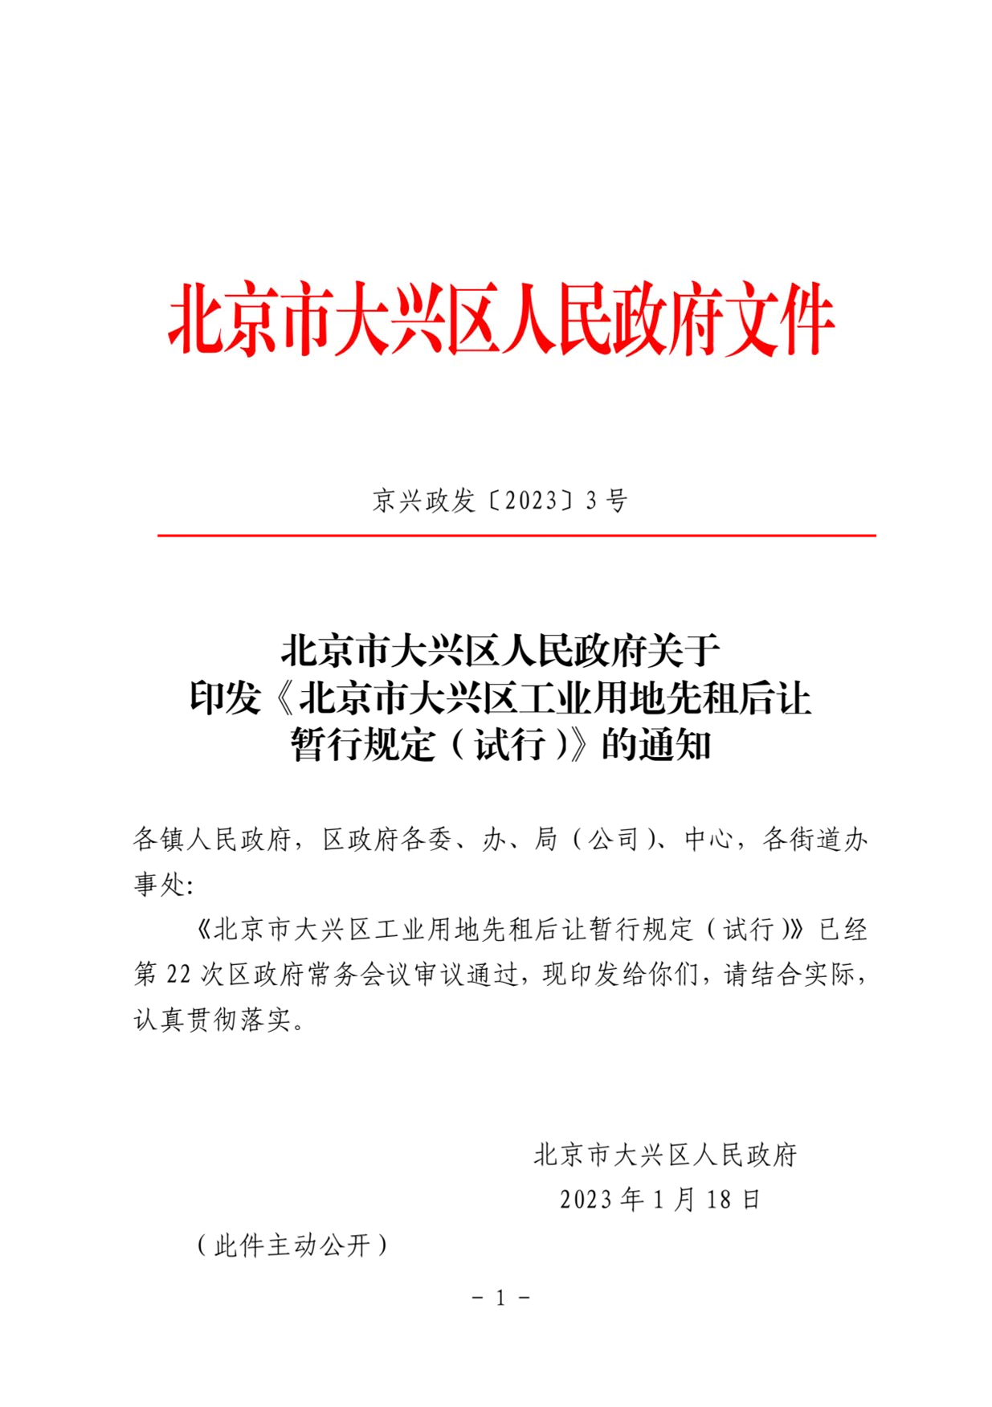

http://172.28.65.229:8080/viewer/pc/index.html?docuri=http://172.28.65.176:8088/seeyon/fileUpload.do?met... 2023/1/19

w 2/6(W)

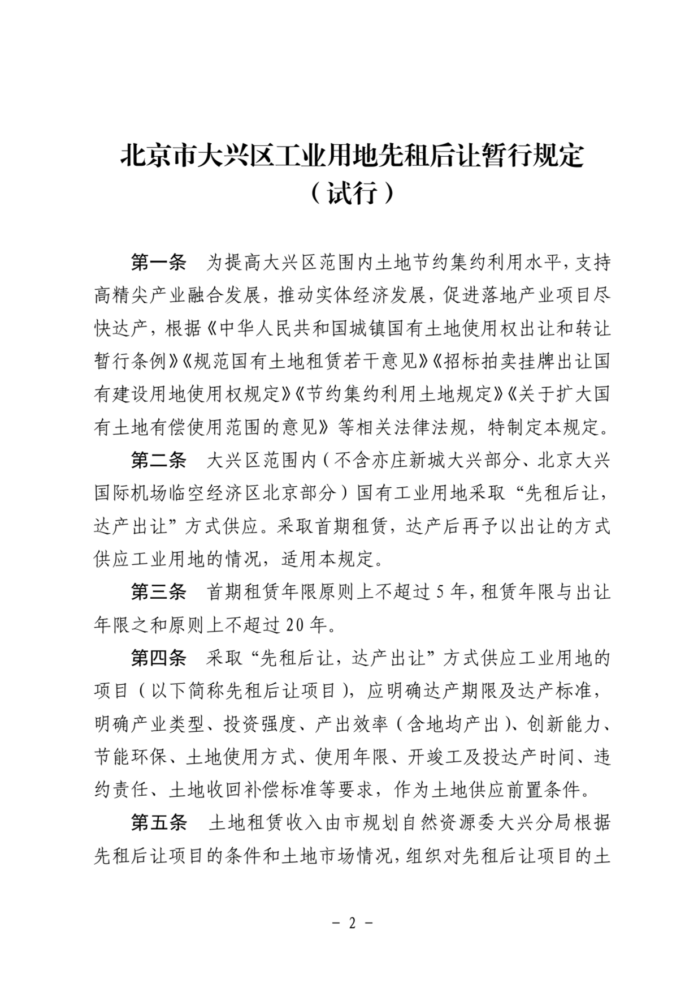

http://172.28.65.229:8080/viewer/pc/index.html?docuri=http://172.28.65.176:8088/seeyon/fileUpload.do?met... 2023/1/19

w 3/6(W)

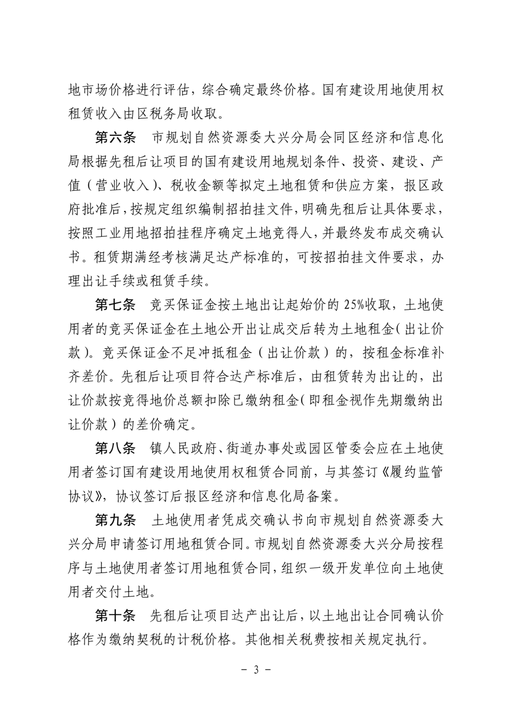

http://172.28.65.229:8080/viewer/pc/index.html?docuri=http://172.28.65.176:8088/seeyon/fileUpload.do?met... 2023/1/19

w 4/6(W)

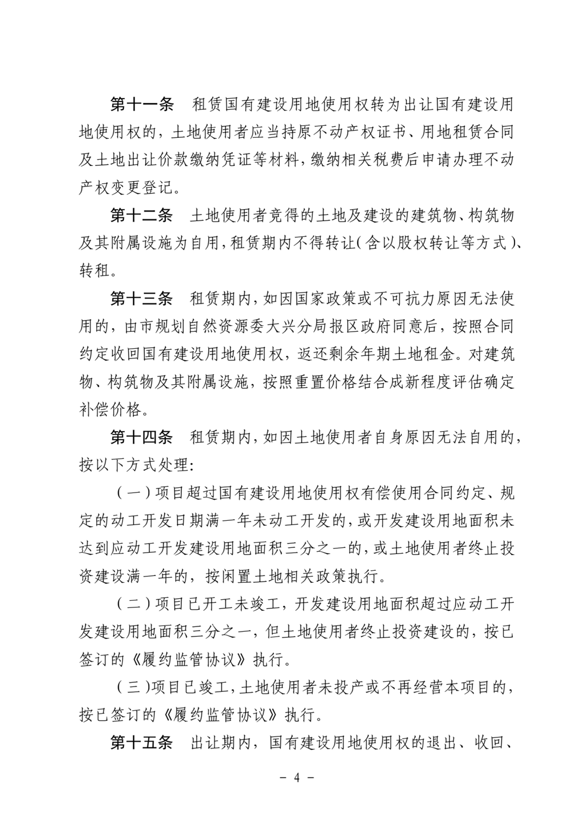

http://172.28.65.229:8080/viewer/pc/index.html?docuri=http://172.28.65.176:8088/seeyon/fileUpload.do?met... 2023/1/19

w 5/6(W)

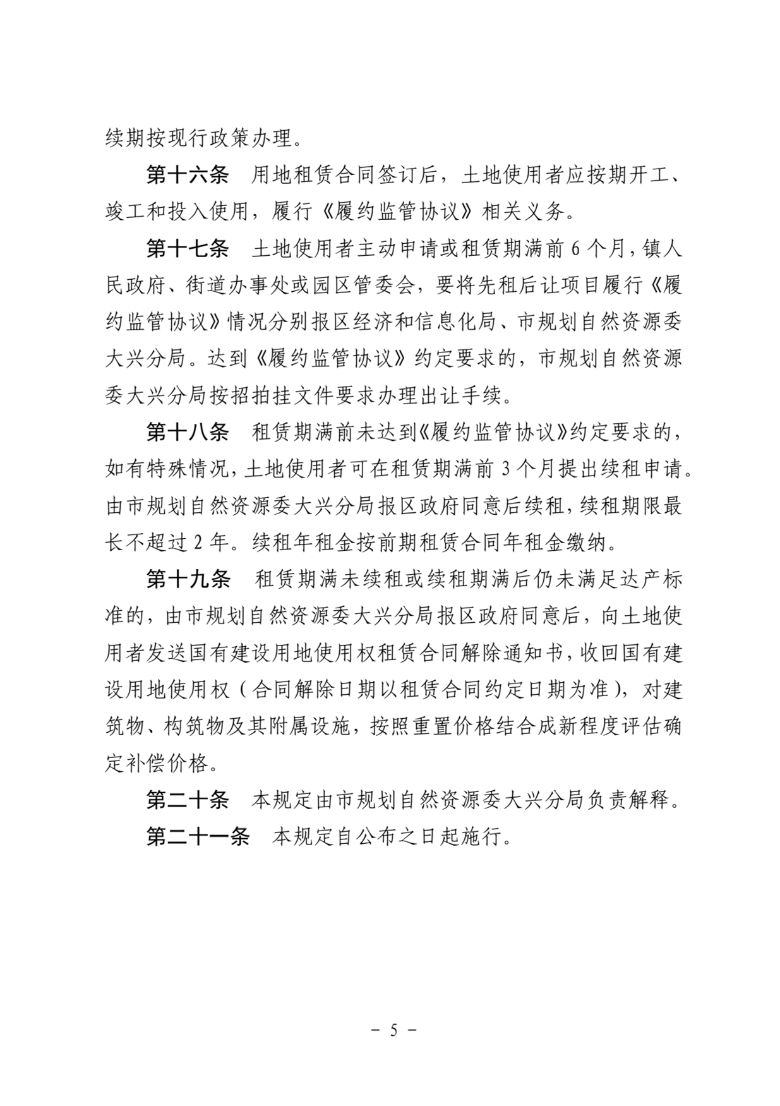

http://172.28.65.229:8080/viewer/pc/index.html?docuri=http://172.28.65.176:8088/seeyon/fileUpload.do?met... 2023/1/19

w 6/6(W)



http://172.28.65.229:8080/viewer/pc/index.html?docuri=http://172.28.65.176:8088/seeyon/fileUpload.do?met... 2023/1/19